Business Case Template

Hepatitis C Test & Treat Nurse-Led Community Based Service

[Name of relevant clinician/manager]

Version [n.n]

dd Month yyyy

Amendment History

Issue | Date | Author | Reason

Distribution List

Name | Department / Organisation

Contents

 |  | Page
1 | Template Summary and Guidance | 3
2 | Background | 4
3 | Aim and Objectives | 5
4 | Policy and Evidence | 6
5 | Planned Service delivery | 9
6 | Service benefits | 10
7 | Resource Requirements | 11
8 | Conclusion | 11
9  10 | Acknowledgements  Appendices | 12  13

1. Template Summary and Guidance

The purpose of this business case template is for use in local health systems, in order to establish an integrated community based nurse-led hepatitis C virus (HCV) service to engage people who inject drugs (PWID) through the funding of a specialist hepatitis nurse. The template should be locally amended to include local data and to fulfill local service requirements.
----------
The epidemiology and demography of hepatitis C virus (HCV) infection varies significantly in different parts of the country, and it is unlikely that a single model of service delivery will be optimal in all locations, i.e. there will not be a “one size fits all. Networks with a geographically small but densely populated catchment areas may be able to deliver the majority of their care centrally, while those with large areas to cover will need to establish multiple outreach services and would be expected to enrol multiple local providers as part of a network. Specific local models are likely to be needed to provide a service to prisons and other secure environments. Whilst this business case template is based on a community hepatitis nurse, it may be that other individuals would be delivering the community service for e.g. addiction nurse specialist or a pharmacist. Additionally, the location of the community service could vary for e.g. substance misuse service primary care, pharmacy, and homeless hostels. Finally, while this business case is focused on PWID, it could also be adapted for other vulnerable adults to include the homeless and the immigrant populations. In some places greater use of technology may allow some ‘virtual’ management of patients.

Therefore this template needs to be adapted according to local needs. Each section will need adjustments based on local differences in epidemiology and where a different community based setting is proposed. This business case includes:
- This template summary.
- Background - This section references the Brighton based service which is used as the basis for evidence for the community model of HCV testing and treatment. It also summarises the national and international context of HCV.
- Aim and Objectives - This provides a clear aim and objectives that will apply in most settings.
- Policy and Evidence - This section details the International and National Policy including targets. The section also includes the data from Brighton that shows how effective the service has been and details the Public Health Outcomes relating to Hepatitis C. This section also includes a table for addition of local data - HCV testing and treatment and Public Health Outcomes data.
- Planned Service Delivery - This provides details of the service provided in Brighton.
- Service Benefits
- Resource requirements - This section reflects the national resourcing
- Conclusion
- Acknowledgements
- Appendices

2. Background

This business case supports the development of an integrated community based nurse-led HCV test, stage & treat service for vulnerable adults who inject drugs. This would be based in the local community service that would best suit the epidemiology of the local population.

The business case is modelled on a recently mainstreamed service developed in Brighton & Hove. The information and data used to support this business case is taken from scientific conference publications and personal communications with the Academic Hepatology lead at the Brighton & Hove service. The acute hospital trust, Brighton & Sussex University Hospital, employed a specialist nurse who worked full time in the community based SMS. For the purposes on this document, the term 'the Brighton Service' will be used.

The importance of the Brighton Service is the delivery of a fully operational integrated nurse-led HCV specialist service in a non-acute, community setting. In England, the majority of HCV treatment specialist clinics are delivered in an acute hospital setting, which had previously been the case in Brighton. The difficulty this presents is that 90% of individuals with HCV in England people who inject drugs (PWID)², a highly vulnerable and disenfranchised cohort with poor engagement with health services. In 2011, with help of research funding, Brighton appointed a hepatitis nurse to work at the Substance Misuse Service to perform blood borne virus (BBV) screening with onward referral to the hospital. Only 5% of those referred actually attended their hospital appointment with none being eventually treated.

The WHO Global strategy on viral hepatitis aims for elimination of viral hepatitis as a major health burden by 2030. This WHO target is unlikely to be achieved without directly engaging PWID; only by reducing seroprevalence in this cohort will HCV elimination be a realistic goal. In England, the HCV services are now delivered within the framework of HCV Operational Delivery Networks (ODNs). A national CQUIN (Commissioning for Quality and Innovation framework for payments) is used to support delivery of HCV services through stewardship and measures the effectiveness and cost of treatment of patients within a nationally agreed run rate per network. There is also a governance payment for each network which is expected to be used for network development and is awarded retrospectively on the submission of quarterly evidence. The Brighton specialist nurse post positively contributes to the CQUIN achievement and is a model the network is intending to roll out in East and West Sussex. Brighton is the hub for the Sussex ODN where there is a weekly multi-disciplinary team (MDT) to discuss potential HCV treatment patients.
3. Aims & Objectives:

Aim
- To reduce the morbidity and mortality from HCV related liver disease and as a consequence of treatment, reduce onwards viral transmission; in order to achieve national and WHO targets for elimination of viral hepatitis as a major health burden by 2030

Objectives
- To provide a nurse-led community based test-stage-treat service for those at risk of HCV infection with Hepatologist and multidisciplinary team support
- To access ‘hard to reach’ PWID at high risk of HCV infection in a local Substance Misuse Service and ensure continuity of care
- To provide HCV testing with dried blood spot testing and pre and post-test discussion.
- Utilising transient elastography (mobile Fibroscan) to provide onsite non-invasive staging of liver scarring (fibrosis)
- To work up patients for referral for MDT assessment
- To provide onsite treatment following MDT assessment (with the supervision of the Consultant Hepatologist)
- To provide multidisciplinary support to the specialist hepatitis nurse
- To work with managers and commissioners to ensure high quality and effective service delivery including achieving local and national HCV targets

4. Policy & Evidence:

Policy Guidance
- Viral hepatitis is the leading cause of death globally (1.46 million deaths in 2013), compared to HIV (1.3 million), TB (1.2 million) and malaria (0.5 million). In 2016, WHO developed a strategy to tackle hepatitis with targets for viral hepatitis control:
- Ensure that 30% of people infected with HCV are aware of their status in 2020 and 90% in 2030
  - Reduce HCV related mortality by 10% in 2020 and by 65% in 2030
  - Reduce new HCV cases by 30% in 2020 and 90% in 2030.
  - In the UK, mortality has remained stable year on year with a reduction of 8% in 2015, probably related to greater access to new direct acting antiviral (DAA) drugs.,,
- According to UK surveys, only half of PWID were aware of their HCV status.9 Public Health England shares the WHO vision to halt transmission and ensure all those infected are offered safe and affordable care and treatment.⁵ UK data supports progress towards the WHO targets 2020⁵, but more work is needed to meet the 2030 targets.
- NHS England has produced a service specification for Operational Delivery Networks to provide specialist oversight of hepatitis C treatment including the five domains of the NHS Outcomes Framework (preventing people from dying; enhancing the quality of life; helping people to recover; ensuring a positive experience; and treating and caring in a safe environment). NHS England provides funding to improve HCV Treatment Pathways through Operational Delivery Networks. These payments are made directly to each NHS trusts where they are part of an ODN.9 A national CQUIN is used to support delivery of HCV services through stewardship and measures the effectiveness and cost of treatment of patients within a nationally agreed run rate per network. The governance payment for network development, is awarded retrospectively on the submission of quarterly evidence.

Activity
The Brighton Pilot was a 4-year Integrated Test-stage and TREAT (ITTREAT) community HCV project (December 2013-2017) Ethical approval was obtained (REC ref 13/EM/0275). Research funding ran out in Dec 2017, but a subsequent successful business case was presented to the Brighton and Sussex University Hospital NHS Trust. This has ensured permanency of the community nurse and will allow this service to run for the foreseeable future.

Project ITTREAT is based at a local substance misuse service (SMS) and has recruited 550 individuals to date of whom 250 (45%) are HCV PCR positive. Despite a mean age of only 40 years, 43% of individuals who underwent community fibroscan had clinically significant liver scarring (fibrosis). Approximately 179 (72%) individuals have been suitable for HCV treatment, of which 116 have commenced/completed treatment in the community with treatment outcomes comparable to secondary care (SVR12 rates of ~90%). In 2016/17, 34 patients were treated as part of the service; this is 15% of the total treated in all Sussex. In 2017/18, there are 32 treated to date, which is 17% of the treatment run rate year to date. Appendix A details the most recent presentation for this work (presented at the British Viral Hepatitis Group (BVHG) and British Association for Study of Liver (BASL) Best Practice for ODN Stakeholders meeting Jan 2018). Additional qualitative, health economic and patient reported outcomes are also being collected and will be analysed at a later date.

Table 1 shows local, regional and national Public Health England data for Hepatitis C (Public Health Outcomes Framework - Public Health Profiles):
- Detection rate of confirmed cases of Hepatitis C per 100,000 is higher in Brighton
- Percentage of PWID in Substance Misuse Services, who have an HCV test (2014/15), was 92.6% in Brighton and Hove, which is higher than both the regional and national percentage.
- Hospital admission rates for Hepatitis C related End Stage Liver Disease (ESLD)/Hepatocellular carcinoma (HCC)
- In Brighton and Hove since 2001 until 2011, under 75 mortality rates for HCV related ESLD and HCC has been 29.7/100,000 (2001-2003 rolling average), considerably higher than the national rate (0.72/100,000). In 2013-2015 this has reduced to 1.4/100,000, which is approaching the national average. This suggests a correlation both with the advent of new direct acting antivirals (DAA) and the local ITTREAT project

Table 1: Local Data

Use this table to add you own local and regional data.

Public Health Outcomes Framework | Time period | Local (B&H) | Regional  (South East) | National (England)
Hepatitis C detection rate/ 100,000 | 2016 | 58.4 | N/A | 19.7
% PWID in Substance Misuse Service with HCV test | 2014/15 | 92.6% | 85.4% | 81.5%
Hospital admission rate for hepatitis C related end stage liver disease/hepatocellular carcinoma | 2012/13-2014/15 | 4.8 | 1.9 | 2.4
Under 75 mortality rate from HCV related ESLD and HCC | 2014-16 | 1.12 | 0.58 | 0.67

5. Planned Service Delivery

The purpose of this business case is to establish an integrated community based nurse-led HCV service through the funding of a specialist hepatitis nurse.

This Nurse led service provides:
- An autonomous community specialist nurse led service for people with viral hepatitis undergoing treatment, within an integrated team structure of doctors, nurses, Psychiatrists, drug and alcohol workers, peer mentors, social workers, Pharmacist and Pathway Administrator.
- Community nurse-led assessments for patients with viral hepatitis
- Clinical assessment of new and follow up patients who attend the community hepatitis clinics, including performing fibroscans.
- Treatment Initiation, monitoring and adjustment as necessary, in conjunction with and under supervision of a Hepatologist
- A plan of care for all patients in accordance with agreed protocols and clear patients records
- Blood sampling from patients, adhering to the venepuncture in Adults Policy
- Patient follow up in the community as appropriate (including home visits and phone consultations)
- Ensure all relevant information/literature is made available enabling patients to make informed choices regarding treatment
- Expert nursing advice and support to patients, their significant others and healthcare professionals following diagnosis and throughout treatment as part of the MDT
- Continuity of evidence-based nursing care, assessing health, health related and nursing needs of patients and their significant others
- Effective care as part of the MDT, including: managing a patient caseload of patients on antiviral therapy; monitoring of viral hepatitis patients who have not responded to treatment, are not suitable for treatment and those who have declined treatment; ordering diagnostic tests as per agreed protocols and pathways; making and receiving referrals relating to antiviral therapy issues; monitoring and interpreting blood results; home visits if clinically indicated; regular education of drug and alcohol workers, psychiatrists, peer mentors, social workers and General practitioners including training in BBV testing
- Performing HCC and variceal surveillance in those with HCV related cirrhosis according to guidelines and in conjunction with specialist MDT
- Develop, implement and evaluate integrated care pathways and systems of documentation in collaboration with the MDT.
- Service user involvement in providing feedback of their experience of the current service and suggestions for improvements
- Cross cover for hospital based hepatitis clinics
- Establish and co-ordinate patient support forums/groups

6. Service Benefits

This service will ensure a targeted approach to PWID through a multidisciplinary one-stop service. The Brighton data indicates the value of providing a community-based HCV service for delivery in SMS settings. Such a strategy represents patient centred care with the potential to: provide opportunities for earlier intervention, improve diagnosis rates; improve linkage to care rates, and improve treatment outcomes aligned to national commissioning guidance. This innovative pathway will also contribute to reduction in HCV related morbidity and mortality, onwards viral transmission, and health inequalities.

The local Brighton data corroborate this: The unlinked Anonymous Monitoring Survey of People who inject Drugs (Brighton Summary 2005-15) show that compared to 2013, in 2015 two years after project ITTREAT commenced, HCV seroprevalence amongst PWID reduced from 70% to 50%. In addition the local Public Health Outcomes Framework shows improvements in local indicators (Table 1).

Project ITTREAT has provided a service model for replication across the country, and has been presented at:

- Public Health England/ HCV Action meeting Brighton (Nov 2015)
- European Liver meeting (EASL), Apr 2015 and American Liver meeting (AASLD), Boston Nov 2016
- BVHG meeting, London, Mar 2017 (obtained highest feedback score 4.86/5)
- Regional British Society of Gastroenterology Meeting (BSG), London, Feb 2015 (Best Poster) and Mar 2017
- Hepatology Matters Meeting, Birmingham, June 2017
- International Symposium on Hepatitis C in Substance Users, New Jersey, Sept 2017
- American Liver Meeting (AASLD), Washington, Oct 2017
- BVHG/BASL Best Practice for ODN stakeholders meeting, Manchester, Jan 2018

7. Resource requirements:

NHS England provides funding to improve Hepatitis C Treatment Pathways through Operational Delivery Networks. These payments are in two elements:
1. Governance and Partnership Working;
2. Stewardship and NICE guidance compliance

These payments are made directly to each NHS trusts where they are part of an Operational Delivery Networks (ODNs). A national CQUIN is used to support delivery of HCV services through stewardship and measures the effectiveness and cost of treatment of patients within a nationally agreed run rate per network. The governance payment for each network, which is expected to be used for network development, is awarded retrospectively on the submission of quarterly evidence. BSUH and the Sussex network met all the criteria in 2016/17 and are expecting to do the same in 2017/18. The CQUIN is of 3 years and 2017/18 is Year 2.

The cost of a Band 7 specialist hepatitis nurse is £31,696-£41,787. The post generates income through the CQUIN and tariff once the service is up and running.

The service secured funding for a portable fibroscan at a cost ranging from 30-50K. However the fibroscan is not essential as other non–invasive markers such a blood tests can be used (APRI, FIB-4 test). Nonetheless the Brighton team has found the fibroscan to be a strong facilitator for engagement.

The Brighton service has kindly agreed to share their own data (see Appendix B).

8. Conclusion

This service has demonstrated a clinically effective model for delivering accessible community based test and treat HCV services:
- Access the vulnerable client group
- Deliver on WHO and PHE targets
- Deliver NHSE run rates and CQUINs
- Generate income for the service once established

This service is an innovative and ground-breaking service that is expected to be replicated nationally as part of HCV CQUIN developments. The post holder has been largely responsible for the success of this project. This is due to her expertise in both addiction medicine and viral hepatitis, her passion to engage with vulnerable adults to provide holistic care and her ability to work with drug and alcohol workers, peer mentors, social workers and psychiatrists in a multidisciplinary manner.

9. Acknowledgements

This business case template is based on data from a pilot study undertaken in Brighton. Therefore acknowledgements to Dr Sumita Verma, Reader in Medicine Brighton and Sussex Medical School and Hon Consultant Hepatology, Brighton and Sussex University Hospital, Specialist Hepatitis Nurse Margaret O'Sullivan, Brighton and Sussex University Hospital and to all other staff at Brighton services (acute trust, substance misuse & public health) who have supported this important HCV development. Thank you to Alison McKinlay, Service Manager Brighton and Sussex University Hospital, for sharing the BSUH business case and local financial data. The template has been funded and commissioned by Gilead Sciences Ltd. Gilead had no editorial control over the document.

Appendix A
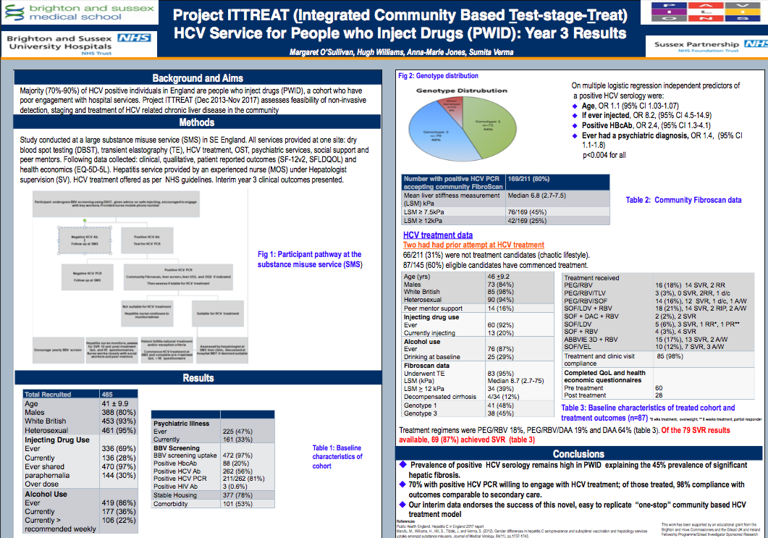

Appendix B - Brighton Service data

Table 2 describes the additional clinic activity in Brighton and associated costs:

Table 2 Additional activity
 | Units | £
New clinic activity | 428 | 34,240
New Telephone clinic activity | 450 | 10,350
Total | 878 | 44,590

The weekly schedule for this post is shown in Table 3. The post offers daily face-to-face clinical time, telephone clinics and domiciliary visits. Due to the nature of delivering this direct clinical activity with the group of patients identified above, clinic times are used flexibly with undertaking other work such as clinical administration (e.g. reviewing results, clinic letters), engaging with patients and support workers via regular networking, teaching and training.

Table 3 Weekly Schedule
 | AM | PM
Monday | TELEPHONE: 20-30mins  Non direct clinical activity | 14:00-17:00 Clinic (3hrs)  Non direct clinical activity
Tuesday | 0930-12:30 clinic (3hrs)  Non direct clinical activity | 13:00-16:00 Drop in Clinic (3hrs)  Non direct clinical activity
Wednesday | DOM, Telephone clinic 20-30mins | 13:00-17:00 Clinic (4)  Non direct clinical activity
Thursday | DOM | 13:00-17:00 Clinic (4)  Non direct clinical activity
Friday | Telephone clinic 20-30 mins  Non direct clinical activity | 13:00-15:00 Clinic (2)  Non direct clinical activity

Table 4 provides a template for local areas to add their own data.

Table 4 - Financial Information
Income | 44,590
Pay | 26,500
Non-Pay
EBITDA | 18,090
Depreciation
Surplus / (Deficit) | 18,090
Capital (including irrecoverable VAT)
Cost Improvements (included above)
Transitional Costs (included above)

NHS England. HCV Networks https://www.england.nhs.uk/commissioning/wp-content/.../hep-c-networks-spec.pdf
Marufu M, Williams H, Hill SL, Tibble J, Verma S. Gender Differences In Hepatitis C Seroprevalence And Suboptimal Vaccination and Hepatology Services uptake Amongst Substance Misusers. Journal of Medical Virology, 2012 Nov; 84:1737-43
WHO target
NHS England. Improving HCV Treatment Pathways through ODNs. 2016
PHE. Hepatitis C in the UK. 2017 Report.
WHO reference
NHS England. Clinical Commissioning Policy Statement: Treatment of chronic Hepatitis C in patients with cirrhosis. 2015 NHS England B07/P/a. Available from: https://www.england.nhs.uk/commissioning/wpcontent/uploads/sites/12/2015/06/hepc-cirrhosis-polcy-statmnt-0615.pdf.
NHS England. Interim Clinical Commissioning Policy Statement: Sofosbuvir + Daclatasvir/Ledipasvir +/-Ribivirin for defined patients with Hepatitis C. April 2014. NHS England A02/PS/b. Available from: https://www.england.nhs.uk/wp-content/uploads/2014/04/sofosbuvir-pol-stat.pdf
NHS England. Improving HCV Treatment Pathways through ODNs. 2016
Hashim A, O’Sullivan M, Williams H, Verma S. Developing a Community HCV Service: Project ITTREAT (Integrated Community based Test - stage - TREAT) Service for People who Inject Drugs. Primary Health Care Research and Development. 2017 (Dec 4^{th)}
O’Sullivan M, Jones AM, Williams H, Verma S. Project ITTREAT (Integrated Community Based Test-stage-TREAT): HCV Service for People who Inject Drugs (PWID). Presented at the BVHG/BASL Best Practice for Operator Delivery Network stakeholders meeting, Manchester, 11–12th January 2018.
PHE. Public Health Outcomes Framework. www.fingertips.phe.org.uk
NHS England. Improving HCV Treatment Pathways through ODNs. 2016

